**Fertility Optimization Tool**

**USER MANUAL**

**TABLE OF CONTENTS**

Section One: Server Configuration 3

1.1. Overview 3

1.2. Windows Components 3

1.3. Installing ASP.NET v4.5 4

Section Two: Deployment 5

2.1. Overview 5

2.2. Webserver Configuration 5

2.3. Database Configuration 5

**ACRONYMS**

|  |  |
| --- | --- |
| **SQL** | Structured Query Language |
| **CD-ROM** | Compact Disc – Read Only Memory |
| **IIS** | Internet Information System |
| **IP** | Internet Protocol |
| **DVD-RW** | Digital Video Drive – Re-Writable |
| **RAM** | Random Access Memory |
| **DIMM** | Dual In-line Memory Module |
| **NIC** | Network Interface Card |
|  |  |
|  |  |

# Section One: Server Configuration

## Overview

The Fertility Optimization Tool runs off a **Microsoft Windows Server 2008 R2 64-bit** operating system. This section presents the necessary configurations needed to enable proper functioning of the tool



## Windows Components

The Fertility Optimization Tool was built on the Microsoft ASP.NET framework but by default windows components that are necessary for hosting asp.net web applications are not enabled, therefore it’s advisable to enable the relevant components as follows

* Navigate to control panel and select uninstall programs. Click ***Turn Windows features on or off*** link located on the left of the Control Panel Home. This opens a windows features dialog box
* Ensure that the three major features required to host asp.net applications are selected (i.e. Internet Information Services, Internet Information Services Hostable Web Core and Microsoft.NET Framework 3.5.1)

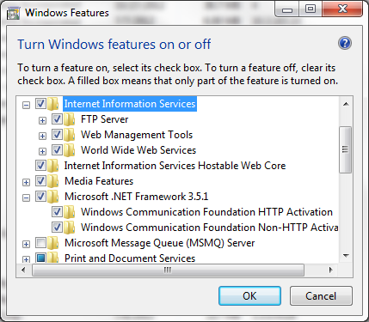

* Click **OK** to proceed and complete the installation which requires a reboot of the system on completion
* After the system reboot check to ensure that a folder path ***C:\inetpub\wwwroot*** is created and typing ***inetmgr*** shotcut in the run programs dialog “ CTL+R“ opens up an Internet Information Service Manager

## Installing ASP.NET v4.5

Enabling of the windows components installs the asp.net v2.0 framework but asp.net v4.0 is also required.

* Browse to <http://www.microsoft.com/en-us/download/details.aspx?id=30653> and click the download button to get an executable offline setup of the Microsoft .NET Framework 4.5

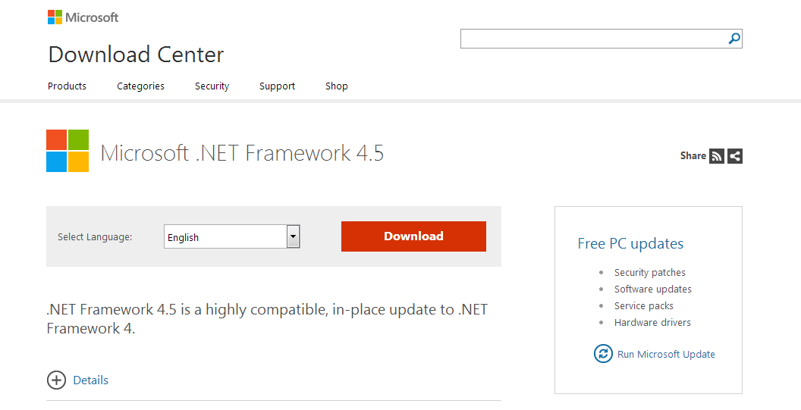

* On completion of the download, run the setup as administrator by right clicking the file and selecting ***run as administrator*** option. Follow the prompts to complete the installation process. On completion the system will require a reboot so as to apply the changes made to the operating system
* After the system reboot open the IIS Manager and check whether ASP.NET v4.0 application pools are added. If successful the server is now capable of hosting both asp.net v2.0+ and asp.net v4.0+

# Section Two: Mobile Client



## Overview

The Fertility Optimization Tool has a mobile client / application which is used to carry out the optimization calculations. This section details what components are available and how to use them

## Webserver Configuration

* Copy and Paste the folders containing the published versions of the solution to the wwwroot folder

## Database Configuration

* Open Microsoft SQL Server 2008 R2 Management Studio which is the software to be used for database management operations. Login with the server instance credentials

# Section Three: Web Client

## Overview

The deployment of The Fertility Optimization Tool involves use of Internet Information Service (IIS) as the webserver and MS SQL Server 2008 R2 for database management

## Webserver Configuration

* Copy and Paste the folders containing the published versions of the solution to the wwwroot folder

## Database Configuration

* Open Microsoft SQL Server 2008 R2 Management Studio which is the software to be used for database management operations. Login with the server instance credentials